CALLING ALL ARTISTS
CHURCH LANE GALLERY
is looking for new members

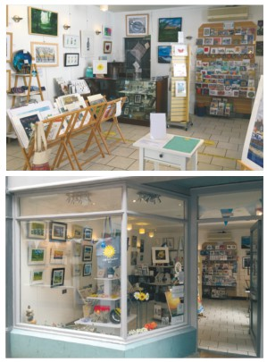

Church Lane Gallery is an inclusive gallery for artists of all kinds in Banbury and the surrounding area; funded and operated by members of Banbury Artists’ Co-operative. We offer affordable town centre space to display and sell quality artwork and crafts.
Opening hours: Weds-Fri 10am-3pm Sat 10am-4pm

3 Victory Buildings, Church Lane, Banbury, OX16 5LT
www.churchlanegallery.co.uk
@churchlanegallery

@ChurchLaneArt
@churchlanegallery
Design and artwork by Rosy Burke www.rosyart.uk
9.2022

CHURCH LANE GALLERY

We are a group of local artists operating as Banbury Artists’ Co-operative who run Church Lane Gallery by ourselves, for ourselves, and to bring local art and craft directly to the public.

The Gallery was set up in 2016 and has many local followers who visit regularly as well as passing tourists. Regular new displays attract more visits.

Members have many opportunities to participate in local festivals and events such as Oxfordshire Artweeks, Cropredy Festival, the Canal Festival and local Christmas markets together with satellite exhibitions. Artists can also share their work with a larger audience on our social media and Gallery website page.

STAFFING AND MEETINGS,
The Gallery is staffed voluntarily by its members. Training will be given to new artists. The Gallery is open Wednesdays to Saturdays inclusive. Members are required to work one and a half days each month (three shifts). Shifts are 10am-12.30pm and 12.30-3pm (4pm on Saturdays). Extra shifts are much appreciated. Hours may be extended during busy periods. Please note that artists who do not meet their staffing obligations will not be allowed to exhibit that month.
Artists are encouraged, where possible, to produce art while staffing as this creates extra interest and draws customers in.

Members meet once a month in person or on Zoom to discuss the running of the Gallery. It is a friendly group and advice from experienced artists can be a great support to new members. Whilst attendance is not obligatory, participation is strongly encouraged. Artists are expected to respond to the requirements and decisions that are made at the meetings.
Members are also encouraged to join one or more of our teams in areas of finance, administration, marketing, refurbishment, and maintenance to ensure the smooth running of the gallery.

REFURBISHMENT
The Gallery is refurbished every two months with a new showcase. Artists and makers submit new work, labelled, priced and ready for hanging, Most artists change a good proportion of their work for each refurbishment as it is important to keep the gallery looking fresh and interesting for the public. New work should be delivered to the gallery, ideally the day before the refurbishment when old work can be collected.

INSURANCE
Members are responsible for the insurance of their own work. Church Lane Gallery has public liability insurance of £5m.

TERMS AND CONDITIONS
Membership is annual, running from April to March. Artists can join Church Lane Cooperative at any time. Membership Fees are currently £25 per month. Commission from sales is currently 20% (October 2022). Both are subject to regular review by Members.
Sales are calculated monthly and payments are paid promptly by Bankers Automated Clearing Service (BACS).
On joining, Members are required to pay a £1 share to become a Member of Church Lane Co-operative. Membership fees are paid monthly in advance by standing order.
Members wishing to cease their membership must notify the Membership Secretary in writing
or by email. Three months notice must be given. Membership Fees are payable within this period and staffing shifts must be done.
Membership entitles artists to display new artworks every two months when the gallery is refurbished.

MEMBERSHIP APPLICATION
Applicants can call into the Gallery to see the displays and for an informal chat to discover the benefits of becoming a member and pick up a Membership Form. On application Artists are asked to provide their social media details such as website, Facebook or Instagram, where their work can be viewed.
Alternatively, photos can be emailed to the Membership Secretary or presented in person or by post to the Gallery. Applications will be assessed by a membership panel who will contact the applicant with their decision.

To apply, please email the Membership Secretary at: picasso@churchlanegallery.co.uk , apply on line or download the membership form at:
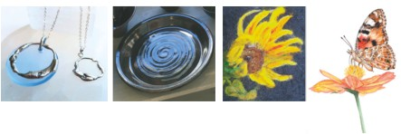
www.churchlanegallery.co.uk/becoming-a-member

